Intent:

|  |  |  |  |
| --- | --- | --- | --- |
| **Communication, language & vocabulary** | **Books and reading** | **Experienced-based learning** | **Knowledge and retaining knowledge** |

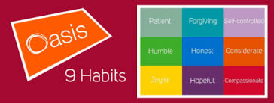

Music makes an important contribution to the life of every school and should be celebrated, promoted and encouraged. It helps build pupils’ self-esteem and self-discipline and leads to high standards across the curriculum … It includes pupils of all backgrounds, interests and abilities.” (Music Mark, the UK association for Music Education)

• The OABL music curriculum is designed to give pupils a wider range of musical experiences than they might otherwise have access to whilst connecting them to the city of Bristol.

• It provides children with a universal language from which they can develop their self-confidence, creativity and sense of achievement.

• Children will experience a variety of instruments played by professional musicians for joy, inspiration and aspiration.

• Opportunities to perform, listen to and critique music across a range of historical periods, genres, styles and traditions underpin the teaching of music across the academy.

• Children will study significant individuals throughout history and be encouraged to inform and develop their own musical preferences.

• Pupils will learn to sing and to use their voices through singing assemblies and annual performances and have the opportunity to play an instrument so they can create music on their own and with others.

• Children will learn to read musical notation and understand how music is communicated through pitch, dynamics and tempo.