Induction
Welcome to
Oasis Academy Bank Leaze

Introductions

Meet the staff

Assistant | Principal | and | EYFS
Lead: Ms | Chambers

Class Teacher: Mrs Neal

Teaching Assistant: Miss Gancareck

Daily Organisation
- Doors open at 8.45am
- Access through main KS1 playground and into the Reception Class.
- Free play on arrival
- Literacy/ Numeracy/ Phonics
- Fruit time
- Playtime 10.25-10.45(KS1 playground)
- Lunchtime 12.00-1.00
- Learning (other subjects)
(collection from the classroom)
- Milk | time
- Home | time | at | 3.15

School Uniform
- Please name all uniform clearly
- PE Kit
- Book Bag
- Dap Bag
- Summer hat
- Please can you put a spare set of clothes in the dap bag.
- The children will get dirty!
You can purchase uniform from the
website. www.myclothing.com

Lunch
  - All children are now entitled to a free school meal – hot dinner, jacket potato or salad bar.
  - Fill in form even if you are not
having the meal please.
  - Clearly named lunch boxes and drinks.
  - Water in the classroom and we have fruit and milk during the day.

Curriculum
  - Early Years Foundation Stage (EYFS)
  - Prime Areas of learning:
- Communication and Language
-Physical Development
-Personal, social and emotional development Specific Areas:
-Literacy
-Mathematics
-Understanding the world
-Expressive arts and design.
Learning through play
- Activities inside and outside
- Parent workshops in Term 1 on how to
support your child with their learning.

Reading
- Yellow reading communication book
- Individual reading book
- Begin looking at books without text, telling own stories from pictures.
- Book bag has to brought in every day.
- Reading is a focus in the Academy.

Assessment
  - Electronic Learning Journals.
  - Information meeting
in term 1.

Attendance
. Alex the Bear is rewarded to children with good attendance
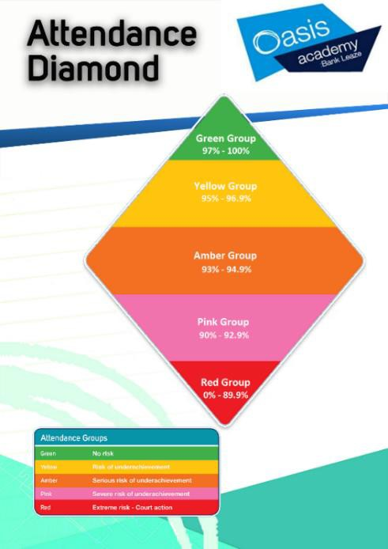
.If your child is not going to be in due to illness please call the Academy.
.Procedures if attendance drops.

As a school we aim to:
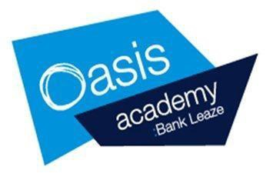
- Maintain an attendance rate of a minimum of 96%.
- Maintain parents’ and
pupils’ awareness of the importance of regular attendance
- Maintain good time keeping

Good attendance is important because:
- Statistics show a direct link between
under-achievement and poor attendance
- Regular attenders make better progress,
both socially and academically
- Regular attenders find school routines, school work and friendships easier to cope with
- Regular attenders find learning more satisfying
- Regular attenders settle into school more
easily

As a parent/carer you can help us by:
- Ensuring your child attends school regularly. Absence should only happen when your child is significantly ill and therefore unfit to attend school, or if there is an unavoidable/unforeseen reason or circumstance which is causing a difficulty.
- Telephoning on the first morning of any absence to give us the reason and tell us when the child is likely to return to school
- Arranging all non-emergency medical appointments out of school hours or during school holidays
- Sending us a note confirming the reason for your
child’s absence when s/he returns to school
- Keeping us updated by telephone or letter if your child has any extended period of absence
- Making sure we always have your current contact numbers; this includes all telephone numbers
(including child minders’) and emergency contact
details

We shall:
  - Always strive to ensure contact with the parents/carers of absent pupils on a daily basis
  - Follow up unexplained absences by phone calls and
letters as necessary
  - Support children and parents who are having difficulties with attendance
  - Publish your child’s attendance rate on her/his annual school report
  - Let you know (in writing) if we have concerns regarding your child’s attendance and punctuality
  - Invite you to meet with the Mrs Kerslake where attendance is not improving
  - Make a referral to the Local Authority Education Welfare Officer, who visits the school regularly to review and support attendance and punctuality issues, if we continue to have concerns
  - Consider the use of parental responsibility measures when poor attendance is continuing.

Categorising Absence
Where pupils of compulsory school age are recorded as absent, the register must show whether the absence is Authorised or Unauthorised.
An absence is only classified as Authorised when a child has been away from school for a legitimate reason and the school has received notification from a parent or guardian.
- Authorised absence may be granted under the following circumstances:
- Exceptional Circumstance
- Exclusion
- Days of religious observance
- Medical/dental appointments that cannot take place out of school hours.
- Illness – with parental consent by phone or a medical note.
- Education off-site
- Education visits e.g. another setting.
- Approved sporting activity
- Interview
- An absence can only be Authorised by the school and cannot be authorised by parents/carers.
- Where there is no explanation for an absence, or where the explanation or reason for the absence is considered unsatisfactory, absence will be recorded as Unauthorised.

Illness

In most cases a telephone call from the parent/carer informing the school that their pupil is ill will be acceptable.
However, if absence levels become a concern for the school, then Parents/carers may be contacted and advised that future absences will no longer be automatically Authorised unless suitable evidence is presented to the school

Medical Appointments

Parents/carers are advised where possible to make medical and dental appointments outside of the school day.
Where this is not possible, pupils should attend school for part of the day. Parents/Carers may be asked to provide evidence of appointment dates/times to allow them to Authorise the absence.

Punctuality

- If a child arrives to school late but before the registers close at 9.00 am, then the child will receive a Late Coding (‘L’ Code).
- If the child arrives after the register close (9.00am) then Department of Education guidance means that the child will be coded as arriving after the registers have closed - ‘U’ Code. The ‘U’ Code is an Unauthorised Absence for the entire session.

Exceptional circumstances and family holiday
- Exceptional circumstances are when the circumstances leading to a
request for absence are ‘of unique and significant emotional, educational or spiritual value to the child which outweighs the loss of teaching time’. The school considers Exceptional circumstances to be
those that are | highly | unlikely to be repeated, or an event or situation
that is unique | to the | children involved and which would not apply to
other children | in the | school.
- In certain circumstances a parent/carer’s employer might restrict annual leave to a certain time period. In these circumstances the school will ask for a written confirmation from the employer and will then consider the request.
- A parent/carer must complete an Absence Request Form from the school
office when asking leave.
- The School will always put the education of the child first when deciding whether or not to Authorise an absence. In doing so, the school will also take into account the child’s prior attendance, age, stage of education, internal assessment weeks and educational progress when making a decision.
- If a request is Unauthorised and the leave is taken anyway, then Oasis Academies are expected to inform the Local Authority, who may then instigate a Penalty Notice.

Unauthorised Absences

There are times when children are absent for reasons, which are not permitted by law. These are known as Unauthorised Absences.
Examples of Unauthorised Absence can include:
• | Waiting for a delivery
• | Going for a family day out
• | Sleeping in after a late night
• | Going shopping or for a hair cut
• | Because it is your child’s birthday
• | Term time holiday/Cheap flights
• | Parent’s illness

Monitoring Absence
We are keen that parents should realise when their child’s attendance rate has slipped. We will regularly closely monitor attendance. An attendance rate of 90% means that in the whole school year of 190 days, there would be 19 days of schooling missed. This is nearly 4 weeks in a year and understandably will have an impact on a child’s attainment.
An attendance of 90% and below falls into the persistent absence category, as defined by the Department for Education.

Induction 2020

  - September 2020
  - Welcome pack (Activities for Summer)

Any Questions?

https://www.oasisacademybankleaze.org/c urriculum/nursery

