Intent:

|  |  |  |  |
| --- | --- | --- | --- |
| **Communication, language & vocabulary** | **Books and reading** | **Experienced-based learning** | **Knowledge and retaining knowledge** |

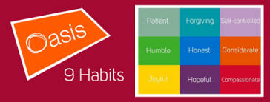

*‘We want to raise the literacy achievement of children by putting quality children’s literature at the heart of all learning.’- CLPE 2020*

* At Oasis Academy Bank Leaze we aim to provide a high-quality Literacy education which see every child leave our school a reader and with the basic literacy skills needed to be successful in the future.
* At OABL, high-quality texts, often taken from the Power of reading, form the cornerstone of the curriculum. In all classrooms, books underpin the provision and enable us to develop readers and writers who have the language, understanding, skills and behaviours to stand confidently on a global platform and overcome any challenges that the modern world presents.
* In reading, we aim to develop children not just as confident readers with the basic skills needed to approach new and challenging texts and a level of reading that is needed to be successful in their future pursuits but to also develop a love of reading for life. When children leave OABL we aim for them to leave as lifelong readers who are excited about books.
* At OABL, are provided with opportunities to experience reading through a variety of fiction, non-fiction and different genres
* In Writing, we aim to develop children as confident writers that are able to communicate through written work. We aim for children to be able to respond appropriately to what they have read and write for a variety of real life contexts; considering why they are writing and who they are writing for.